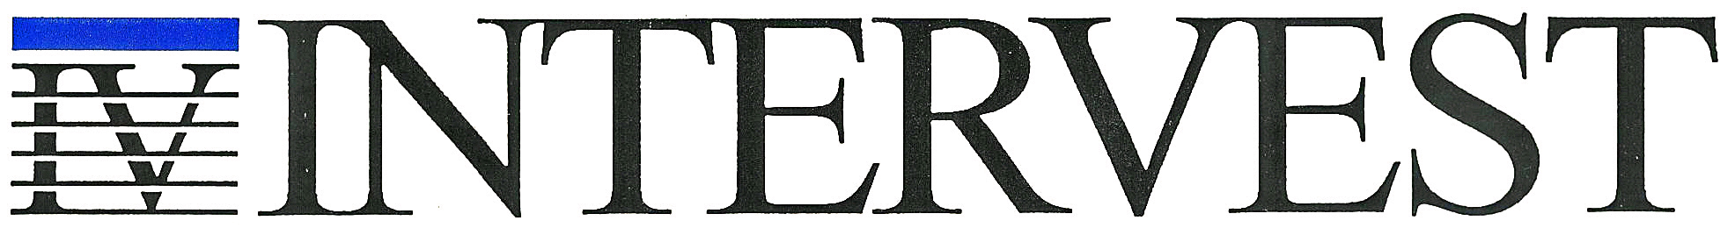

Hold Harmless Agreement for Subcontractors

The subcontractor ______________________________________shall hold harmless and indemnify INTERVEST Construction Corp. against all claims, suits, actions, costs, counsel fees, expenses, damages, judgments or decrees, by reason of any person or persons or property being damaged or injured by the subcontractor or any of his employees, or in any capacity during the progress of the work, whether by negligence or otherwise.
The subcontractor shall further save and hold harmless INTERVEST Construction Corp. for any injury sustained by said subcontractor or any person or persons acting under direction of subcontractor.
This contract shall apply to all jobs subcontracted by INTERVEST Construction Corp. to __________________________________ from this date forward until cancelled in writing.
DATED this _________ day of ____________________________, 20____

____________________________________
Subcontractor Signature

____________________________________
Subcontractor Printed Name

____________________________________
INTERVEST Construction Corp. Signature

____________________________________
INTERVEST Printed Name



P.O. Box 2118 * Madison, MS 39130-2118 * Calumet Professional Park * 7538 Old Canton Road * Madison, MS 39110-8967
P.O. Box 610 * Decatur, MS 39327 (601) 709-6000 * Fax (601) 709-2350 P.O. Box 185 * Holly Springs, NC 27540-0185

